Write a query to display the username and password of all customers. Give an alias name as USERNAME and PASSWORD. Sort the result based on the Username in ascending order.
Username and password is generated as below
USERNAME: concatenate the customer name with customer id.
PASSWORD: concatenate first 3 character of customer name with last 4 digits of customer

phone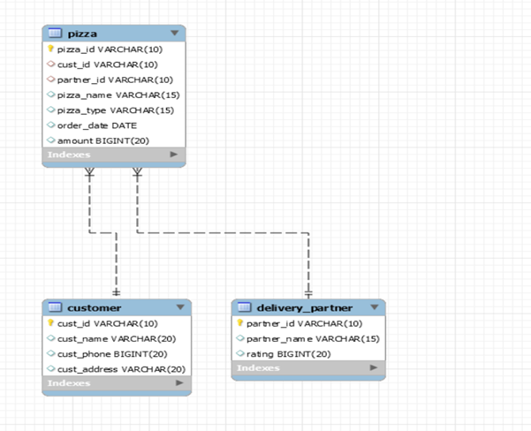
For Example:
cust_id -C001
cust_name – Deepak
cust_phone -7892298767
Output:
USERNAME- DeepakC001
PASSWORD-Dee8767
Design Rules:
1. Use the rules to generate Username and Password.
3. Do not change the name of the column. Please use as per the design rules.
4. Order of the output columns: Username,Password.
5.Sort the results in Ascending Order of Username

